2022 Fall Parent Survey Results

# Survey Responses and Overall Satisfaction

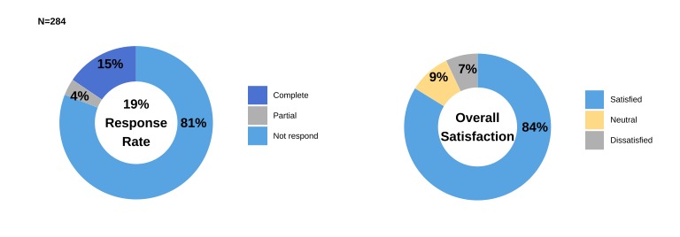

The 2022 Fall Parent Survey received 284 responses, representing a 19% response rate. Among those respondents, 84% of parents are **satisfied** with their students’ experiences at Lasell.

# Satisfaction

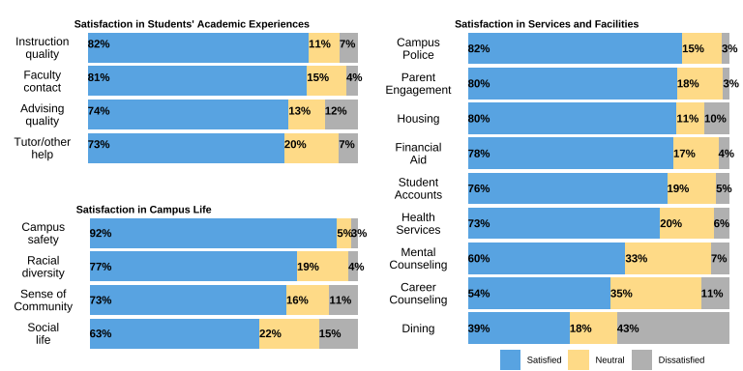

Most of parents are satisfied with students’ academic experiences, campus life, and most of Lasell services and facilities. The highest satisfaction is in **campus safety**, with 92% of parents satisfied in it. Other aspects that have more than 80% satisfaction rate include: instruction quality, faculty contact with students, campus police, parent engagement, and housing.

However, there are a few services and facilities on campus that receive lower than 65% satisfaction rate, including **dining**, **career counseling**, **mental counseling**, and **social life on campus**.

For dining, many parents complain **food availability and quality**. Parents feel the dining hall lack sufficient supply of food when their students cannot eat in **after-hours**. Parents hope that Lasell can have **more food vendors** that are available in late hours. Also, parents complain about food quality and the lack of **healthy food** options. Several parents would like to meet with the food provider or staff members to talk about food options. Some parents suggest Lasell to change to a more student-caring food service provider. Besides, a parent suggest to have **discounted** meal plans for students who only east twice a day.

# Food Committee (FC)

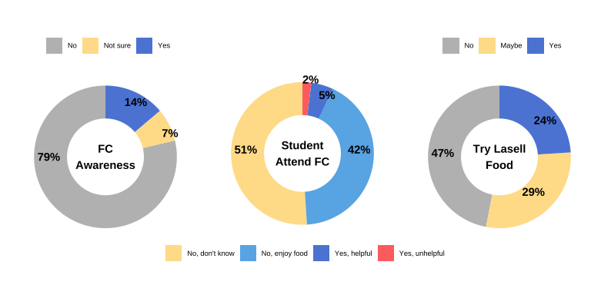

For the student-run food committee (FC), 79% of parents are **not aware** of it, and only 7% of parents think their students attended the FC. 42% of parents think their students did not attend the FC because they enjoy the food. Other parents comment that their students have **schedule conflict** for attending the FC. Parents recommend **web form** as an more accessible and efficient way to give feedback about food.

Another reason for students not attending the FC is the belief that nothing will change no matter what students says in the committee. Parents are upset about the long-exiting complaints about the food, and hope to see if any **actions** are resulted from the FC.

51% of parents may be interested in trying Lasell food. Apart from trying the food, some parents request a **meeting** with the food provider or staff members to talk and offer suggestions about food service at Lasell.

# Information Received

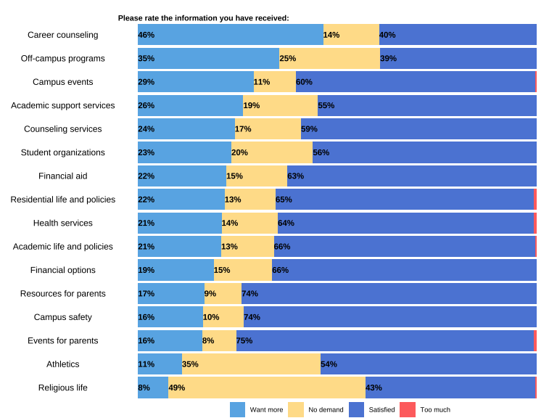

Above 70% of parents are satisfied with information received around events for parents, campus safety, and resources for parents. However, **career counseling** and **off-campus programs** have only 40% satisfaction rate from parents. The **career counseling** also has the most unfulfilled demand, with 46% of parents want more information around career from Lasell.

From parents’ comments, we find parents’ complaints of the current career services being too general. Parents hope students have **major-specific** guidance and learn the **process** of finding a job. Many parents request the career center adviser to offer open discussions with students about **how to identify** good-fit jobs.

In terms of off-campus programs, a few parents suggest to have **RAs** involved in promoting campus activities. Also, a parent recommend to have more or promote any existing events that happen in **Boston city**, which could be a good resource to learn.

# Information Source

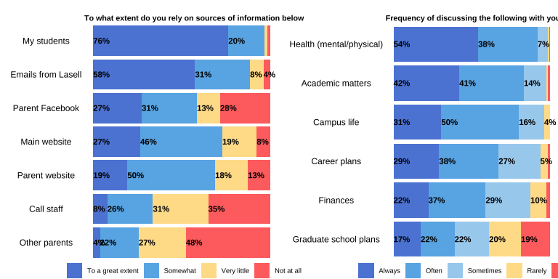

**Students** are the primary source of information for 76% of parents. Meanwhile, 58% of parents rely on **emails from Lasell** as an information source. Parents discuss most frequently with students about **mental/physical health, academic matters, campus life, and career plans**. Other topics like finances and graduate school plans do not happen as often between parents and students. A parent mention that they hope Lasell can provide information about **graduate school** options and the costs and funding for graduate school.

# Events

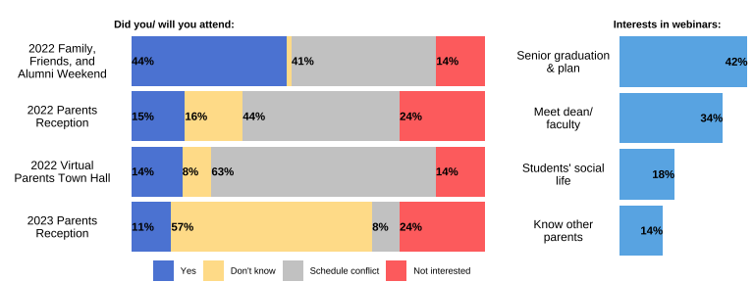

The FFA Weekend is the most popular events among parents, as 44% of parents participated in it. Around 10% to 15% of parents attend or will attend the parent receptions and town hall events. For parents who did not participate, **schedule conflict** is the main reason for missing those events.

Parents who attended the above events enjoyed the events having **diverse options** and being **well-organized**. Parents find the these events a good way to **build community** with other parents and connect to Lasell. A few parents also appreciate the opportunity to **visit the campus** during in-person events. In terms of suggestions, parents hope future events could provide an **event directory**, have some more events on **Sunday** (specific to the FFA weekend), and supply more **food**.

In the spring semester, 42% of parents are interested in a webinar on **senior graduation and plan**. 34% of parents are interested in **meeting with dean and faculty**. Besides, a few parents would like to talk to **RAs** about student life, and learn RA responsibilities and how to seek help from them. A parent with athletic student hope to talk to sport trainers. Some parents also

# Summary

* 84% of parents are satisfied with Lasell overall. **Campus safety** has the highest satisfaction rate, with 92% of parents satisfied in it.
* Dining Services and Food
  + Dining services has the lowest (39%) satisfaction rate. Parents are mainly dissatisfied about the **food availability (late-hour) and quality (healthy food)**.
  + Only 7% parents think their students attended the food committee (FC), and 79% of parents are not aware of the existence of FC. As reflected in parents’ comments, many students have schedule conflict to attend the FC. Some other **accessible** ways of participation (e.g. web forms) may help increase participation. Other students do not believe anything would change from FC. Promotions of any **action** resulted from the FC would help change that belief and increase students’ participation.
  + 51% of parents may be interested in trying Lasell’s food.
* Career Services
  + Career counseling has the most unfulfilled demand, with 46% of parents want more information around career from Lasell. Parents hope students have **major-specific** guidance and learn the **process** of identifying a good-fit job.
* Information
  + **Students** are the primary source of information for 76% parents. 58% of parents also rely on **emails from Lasell** for information.
  + Parents discuss **health** issues most frequently with students. Beyond the different information parents received, some parents request to receive more information around **graduate school** options and costs.
  + Only 40% are satisfied with information received around **off-campus activities**. Parents would like more promotion, probably with the help of **RAs**, for off-campus activities (e.g. activities in Boston city).
* Events
  + Although over 40% of parents missed events due to **schedule conflicts**, parents who attended the FFA, Town Hall, and Parent Reception enjoyed the past events and consider them as well-organized, and a good opportunity to build **community**.
  + In the spring semester, 42% of parents are interested in a webinar on **senior graduation and plan**. 34% of parents are interested in **meeting with dean and faculty**. Besides those offerings, parents would also like to talk to **RA, athletic trainers, and food services** to learn their responsibilities and provide suggestions.